**Level 1: PC Tower Case**

**Outline**

Learn about the internals of a standard PC case by examining physical samples and selecting and labeling images found on-line. Gain deeper knowledge by researching and reporting on specific components.

**Questions**

1. Find one (or more) images that clearly show the internals of a PC Tower Case.   
   (i.e. Google images using keywords “PC Case Internals”)

CPU

R.A.M

Motherboard

Cooling Fan

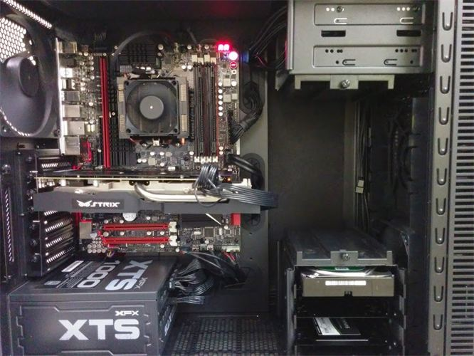



USB expansion ports

Optical Disk Drive



Monitor Port

Ethernet Port





Audio Ports



Graphics Card



Power Supply

Hard Drive Disk

1. Clearly label the following components (using arrows) on your image of the PC case internals:
   1. Motherboard
   2. Power Supply
   3. Hard Disk Drive
   4. Optical Disk Drive (e.g.DVD)
   5. USB Expansion Ports
   6. Monitor Port
   7. Audio Ports
   8. Ethernet Port
   9. Cooling Fan
2. Research more in-depth about “Motherboards”. Make notes on the following:
   1. What different versions are currently available (speed and capacity)

Different types of motherboards that are available are the AT motherboard, BTX motherboard, and etc. Motherboards that are larger have more slots, meaning a lot more capacity to store. Motherboards offer more R.A.M slots going all the way up to 8. Motherboards like the Gigabyte Z390 Aorus Ultra are one of the fastest motherboards (used for gaming).

* 1. How the component has changed since the 1980’s

Back then, there was no separate slot for a graphics card. Now there is a separate slot for graphic cards. The Ram slots back then also only offered them in only MB, and now they have GB.

1. Research more in-depth about “Hard Disk Drives”. Make notes on the following:
   1. What different versions are currently available (speed and capacity)

Types of hard drives are like Parallel Advanced Technology Attachment, Serial ATA, Small Computer System Interface (SCSI), and Solid State Drives. Hard drives with higher density data work faster since it can read the data faster. Hard dive capacities can go up to 8 terabytes.

* 1. How the component has changed since the 1980’s  
       
     Back then hard drives were only available in Gb’s

**NOTE:**

* Download the on-line version of this module (from the class GitHub repository)
* Questions for Level 2 and Level 3 are in the on-line version of this module
* Provide your answers in a MS Word, PowerPoint, or equivalent format
* Upload your answers to your personal GitHub repository

**Level 2: PC Motherboard**

**Outline**

Learn about the structure of a standard PC motherboard by examining physical samples and selecting and labeling images found on-line. Gain deeper knowledge by researching and reporting on specific components.

**Questions**

1. Find one (or more) images that clearly show the layout of a PC Motherboard.   
   (i.e. Google images using keywords “PC Motherboard”)

GPU port

Wi-Fi processor port

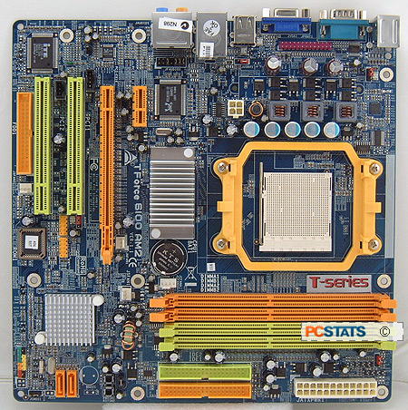





Sound processor port



CPU/Fan



R.A.M memory



SATA ports



IDE ports

1. Clearly label the following components (using arrows) on your image of the PC motherboard:
   1. CPU (and fan)
   2. RAM Memory
   3. Disk Drive Interface (IDE or SATA)
   4. GPU Graphics Processor (either on-board or Graphics Card)
   5. Sound Processor (either on-board or Sound Card)
   6. Wi-Fi / Ethernet Network Interface (either on-board or Graphics Card)

1. Research more in-depth about “CPU Processor Chip”. Make notes on the following:
   1. What different versions are currently available (speed and capacity)

It makes processing faster. As it can address more memory (64-bit).

* 1. How the component has changed since the 1980’s

It was slower and were 8-bit CPUs. It also had low number of slots for Graphics cards/PCI’s/RAM slots.

1. Research more in-depth about “RAM Memory”. Make notes on the following:
   1. What different versions are currently available (speed and capacity)

DDR3 and DDR4 RAM sticks are much faster. Can have up to 128GB of R.A.M

* 1. How the component has changed since the 1980’s  
       
     Back then R.A.M was in MB, and had low amount of R.A.M.

**Level 3: Peripheral Devices**

**Outline**

Learn about how peripheral devices are connected to the back side of a typical PC tower case. Examine physical samples, select and labeling images found on-line and gain deeper knowledge by researching and reporting on specific components.

**Questions**

1. Find one (or more) images that clearly show the layout of the back of a typical PC tower case.   
   (i.e. Google images using keywords “Back Of PC Tower”)

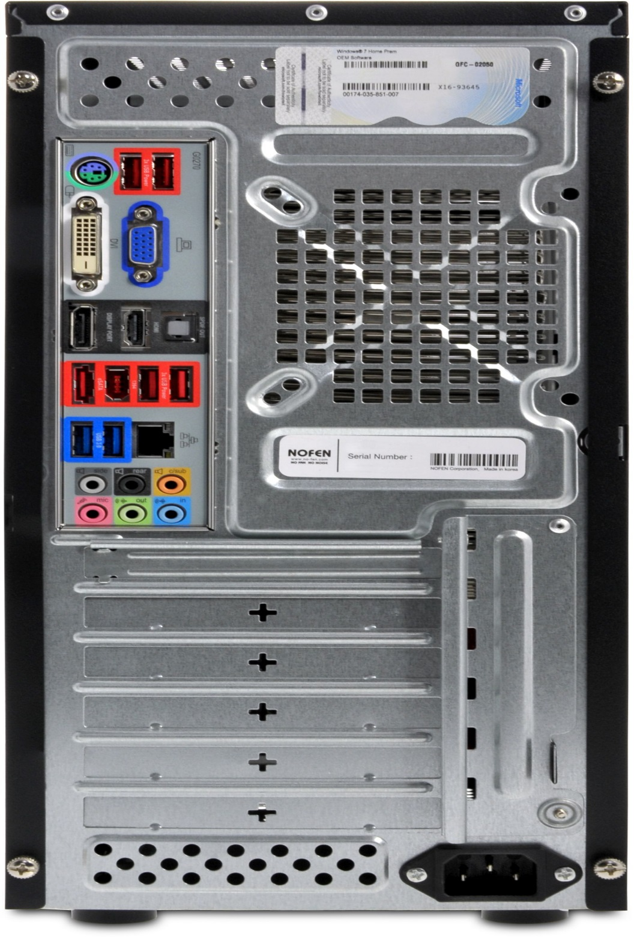

Mouse and Keyboard interfaces





Monitor interface

Ethernet interface



USB ports





Audio inputs/Outputs

1. Clearly label the following components (using arrows) on your image of the back of a typical PC tower case:
   1. Power cord and power switch
   2. Monitor Interface (VGA or DVI or HDMI)
   3. Mouse Interface (USB or PS/2)
   4. Keyboard Interface (USB or PS/2)
   5. USB Ports
   6. Audio Inputs / Outputs
   7. Ethernet Interface
2. Research more in-depth about “Monitor Technology”. Make notes on the following:
   1. What different versions are currently available (e.g. VGA / DVI, Flat Panel Technology))

Panel technologies. The overwhelming majority of computer monitors, laptop screens and tablets are based on TFT-LCD.

* 1. How the component has changed since the 1980’s (e.g. Display Resolution, Technology)

Electrically operated display devices have developed from electromechanical systems for display of text, up to all-electronic devices capable of full-motion 3D color graphic displays. One of the earliest electronic displays is the cathode ray tube (CRT), which was first demonstrated in 1897 and made commercial in 1922.

1. Research more in-depth about “External Portable Storage”. Make notes on the following:
   1. Floppy Disks

Is a type of disk storage composed of a disk of thin and flexible magnetic storage medium, sealed in a rectangular plastic enclosure lined with fabric that removes dust particles. Floppy disks are read and written by a floppy disk drive.

* 1. CD-ROM / DVD / Recordable CD/DVD

CD-ROM: a compact disc used as a read-only optical memory device for a computer system.

DVD: is a digital optical disc storage format invented and developed in 1995. The medium can store any kind of digital data and is widely used for software and other computer files as well as video programs watched using DVD players

Recordable CD/DVD: is a digital optical disc storage format. A CD-R disc is a compact disc that can be written once and read arbitrarily many times.CD-R discs (CD-Rs) are readable by most plain CD readers,

* 1. USB Memory Drives

A USB flash drive is a device used for data storage that includes a flash memory and an integrated Universal Serial Bus (USB) interface. Most USB flash drives are removable and rewritable. Physically, they are small, durable and reliable. The larger their storage space, the faster they tend to operate.

* 1. Compact Flash Memory

In a flash memory mass storage device used mainly in portable electronic devices. The format was specified and the devices were first manufactured by SanDisk in 1994. CompactFlash became the most successful of the early memory card formats, surpassing Miniature Card and Smart Media.

* 1. Cloud Based Storage

Cloud Based Storage: is a cloud computing model in which data is stored on remote servers accessed from the internet, or "cloud." It is maintained, operated and managed by a cloud storage service provider on a storage servers that are built on virtualization techniques.

**Level 4: PC Component Presentation**

**Outline**

Explore the development and features of a specific PC hardware component through deeper research and investigation. Work in partners to create a short presentation. Deliver the presentation to the class.

Each group will research a unique PC hardware component . Your specific topic will be assigned from the list provided below.

**Presentation Structure**

1. Explain what the PC component does and how it fits together with other components to make up a fully functioning PC.
2. Explain how the PC component works. Provide a diagram (image) showing the main parts of the component.
3. Research the current state of the art of the component in terms speed, capacity (size), and other related factors.
4. Research on-line suppliers that sell the PC Component. List the specifications for the available products and the cost (price).
5. Research how the PC component has changed and evolved since the early days of PCs in the 1980’s. Cover each of the following topics separately:
   1. Component Speed
   2. Component Size / Capacity
   3. Two other specifications specific to the PC component (ask Mr. Nestor)

**PC Component Topics**

|  |  |  |
| --- | --- | --- |
| **Topic** | **Partner 1** | **Partner 2** |
| CPU Microprocessor Chip |  |  |
| Motherboard Layout |  |  |
| Computer Graphics |  |  |
| Sound & Audio |  |  |
| Hard Disk Drives |  |  |
| Removable Disk Storage |  |  |
| Network / Internet Connectivity |  |  |
| Mouse / Pointing Devices |  |  |
| Monitor & Display Technology |  |  |
| Printers & Output Technology |  |  |